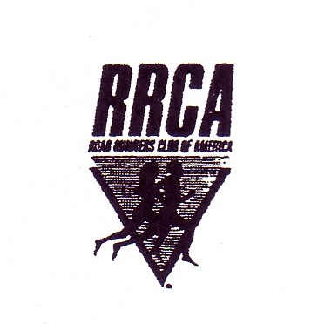The 33rd Annual
Gary Brown Memorial
C&O Canal Five Mile Run

When: Saturday, August 16, 2014, 8:00am start time.

Where: Riverbottom Park, adjacent to the C&O Canal in Williamsport, MD.

Course: Flat, fast “out-and-back” on packed dirt towpath… 80% shaded

Fees, etc: $30.00 if post-marked by August 6th. $40 after August 7th and on race day.
Students $20.00 until August 6th, $30.00 thereafter. Packet pick-up and race
day registration will take place in Riverbottom Park from 7:00 - 7:45 am. Limited to the first 200 entrants.

Awards: All finishers will receive an “OFFICIAL FINISHER” T-shirt. Awards will be presented to the top– three men and women, the top-two masters men and women
as well as the top age group finishers. Awards to top ten high school boys and girls.

Extras: Post race refreshments (fruit, baked goods, sports drinks, etc…). Complete official results promptly mailed to all entrants.

Directions: From US. Interstate 81, take exit 2 (Williamsport, Rt. 11). Proceed south on Rt.
11 for one mile to Artizan Street. Turn left on to Artizan Street and proceed one block to E. Salisbury Street. Turn right on to E. Salisbury Street and go straight for .4 mile to a single lane wood bridge that will bring you into Riverbottom Park.

Contact: Questions, etc… call the Cumberland Valley A.C. phone 301-739-7004 or e-mail race director at mspinnler@cvac-md.us

Detach and Mail

Please clearly print all information

Mail entries and make checks payable to: CVAC, 1012 Valleybrook Dr. Hagerstown, MD 21742

Name
Sex:
Age (as of 8/16/14):

Street Address: City: State:

Zip Code: Phone: (_ _) E-mail:

T-shirt size (circle one) Adult sizes: small medium large x-large xx-large High School Student in 2014-2015?

In consideration of this entry form being accepted. I hereby for myself (my child), heirs, executors and administrators waive and release any claims that I may have against the
Race Officials, sponsors, Town of Williamsport, National Park Service and the Cumberland Valley Athletic Club. I certify that I (my child) am/is physically fit for this event.

Entrant’s signature (parent/guardian must sign if the entrant is under 18): Date:

